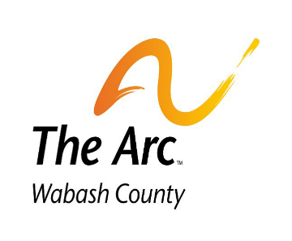

Now Hiring

Communications, Marketing, and Public Relations Coordinator

TITLE: COMMUNICATIONS, MARKETING, AND PUBLIC RELATIONS COORDINATOR (CMPRC), Part-Time 20-29 hours per week, Hybrid – one full day in the main office required.

SUMMARY: The Communications, Marketing, and Public Relations Coordinator (CMPRC) works with the President/CEO to promote the mission of The Arc of Wabash County by executing specific strategic and annual plans that will: 1) Elevate The Arc’s presence, leadership and advocacy role in the greater Wabash County area and region; 2) Build a diverse array of community supports and relationships; 3) Distribute compelling communication to the public, peers, donors, employers, potential participants and the self-advocates we serve; and 4) Lift up voices of local adults and youth with disabilities by sharing their stories of capability, victory and inherent worth. Included in these stories are The Arc staff, volunteers, parents, guardians, and board members who work tirelessly to move self-advocates to the foreground in our communities. The position is both relational and tactical. The CMPRC may also be called upon to support the CEO, Board, Staff, and any hired consultants during other projects.

Contact the Arc Wabash County for a full job description and salary range @ arcwabash.org or 260-563-8411.

